ALPHA & BETA PRUNING

AIM: To implement a python program for Alpha & Beta Pruning algorithm for gaming.

OBJECTIVES:
- To understand the Minimax game-search algorithm.
- To improve Minimax using Alpha-Beta pruning.
- To eliminate unnecessary branches of the game tree.
- To select the best possible move for the MAX player.
- To demonstrate how pruning reduces the number of nodes evaluated.
ALGORITHM:
- Start with the root node of the game tree.
- Set alpha = -∞ and beta = +∞.
- If the current node is a leaf node, return its score.
- For a MAX player, find the maximum value of its children and update alpha.
- For a MIN player, find the minimum value of its children and update beta.
- If beta <= alpha, stop checking the remaining children because they cannot affect the final decision. This is pruning.
- Return the best value to the parent node.
- Select the move having the highest value at the root.
SYSTEM-ARCHITECTURE:
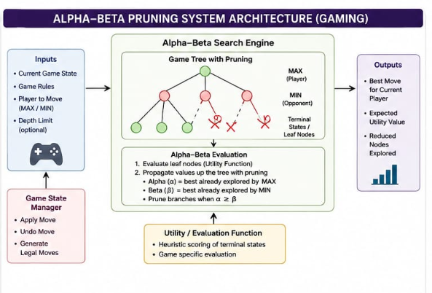

PROGRAM:
def alphabeta(tree, depth, alpha, beta, maximizing):
if not isinstance(tree, list):
return tree

if maximizing:
best = -999
for child in tree:
best = max(best, alphabeta(child, depth+1, alpha, beta, False))
alpha = max(alpha, best)
if beta <= alpha:
break
return best
else:
best = 999
for child in tree:
best = min(best, alphabeta(child, depth+1, alpha, beta, True))
beta = min(beta, best)
if beta <= alpha:
break
return best

game = [[3, 5], [2, 9], [12, 5], [23, 7]]
print("Best Score:", alphabeta(game, 0, -999, 999, True))

OUTPUT:
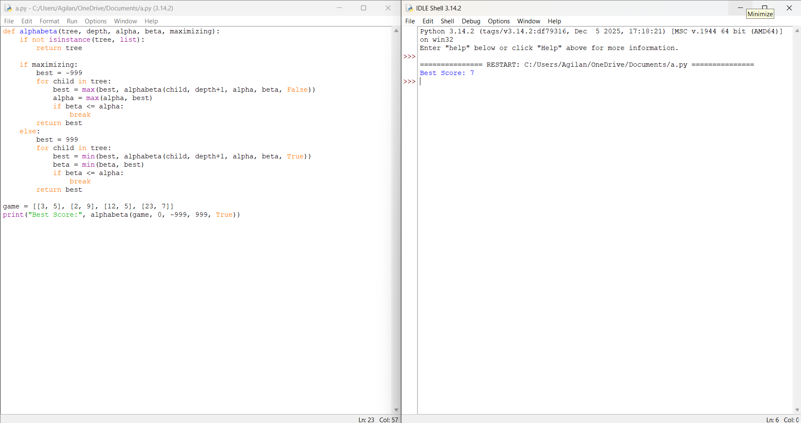

RESULT: Thus the Alpha & Beta Pruning for gaming is implemented successfully using python language.

